ICAI–IFSCA Strategic Collaboration
- The Institute of Chartered Accountants of India (ICAI), through its Global Trade & Services Committee, has established a strategic partnership with the International Financial Services Centres Authority (IFSCA) through an MoU signed on 24 November 2023, valid until 23 November 2026.

- This collaboration focuses on promoting opportunities in international financial services, particularly at GIFT City, and strengthening India’s position as a global financial hub.
Key Highlights
ICAI Delegation to GIFT City (28 August 2025)
- 63 members participated in the delegation
- Visits to NSE IX, Bank of Baroda (IBU), and DevX
- Guided tour of GIFT City
- Networking dinner ahead of the GCC Summit
IFSCA Chintan Shivir (11 September 2025)
- Roundtable interaction at GIFT City
- Engagement with key industry stakeholders
Webinar (September 2025)
- Theme: India as the GCC Capital / Gateway to Growth
- Focus on India’s role as a global capability hub
Knowledge Publication
- Joint publication on Opportunities in GIFT IFSCA
- Covers regulatory framework, opportunities, and business potential
Policy & Regulatory Impact
- MoU signed during GloPac Event (Ahmedabad)
- Recognition under IFSCA Act (Notification dated 18 January 2024)
- ICAI’s proposal accepted by the Government of India
Services Recognized
- Book-keeping
- Accounting
- Taxation
- Financial Crime Compliance
Stakeholder Engagement
- Meeting with Chairman, IFSCA (18 August 2023)
- Discussions on MoU scope and joint initiatives
- Engagement with Department of Economic Affairs (DEA) on policy matters
Impact
The ICAI–IFSCA collaboration continues to:
- Create awareness on GIFT City opportunities
- Build professional capacity
- Support policy advocacy
- Enable global opportunities for Chartered Accountants

Glimpses from ICAI–IFSCA Collaborative Initiatives
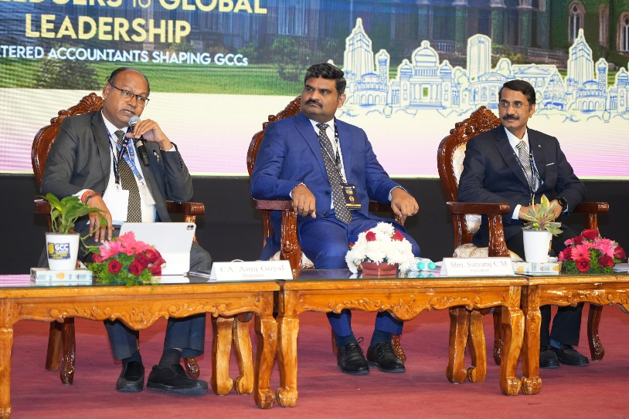
ICAI GCC Summit events in Bengaluru
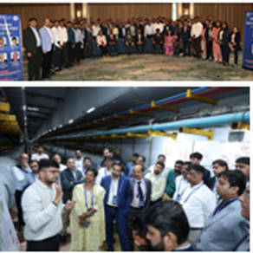
Members’ Delegation to IFSCA
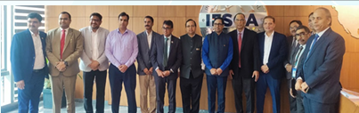
Participation in the IFSCQ Chintan Shivir 2025 roundtable interaction held on 11th Sept. 2025, at Gift City, Gandhinagar

